EverShop: An Open-Source TypeScript Ecommerce Platform
Welcome to EverShop, a modern, open-source Node.js ecommerce platform built with TypeScript, React, and GraphQL.
EverShop is designed to help developers create powerful and flexible e-commerce stores. It features a modular architecture that allows for extensive customization of both the admin panel and the front store, giving you complete control over your application.
EverShop is free and open-source. The source code is available on GitHub.

Core Philosophy
- Developer-Centric: Built by developers, for developers. EverShop provides a flexible and powerful foundation to build upon.
- Open Source: We believe in the power of community. EverShop is free, open-source, and ready for you to make it your own.
- Performance: With server-side rendering and a modern stack, EverShop is designed for speed and a great user experience.

Key Features
- Modern Tech Stack: Built with Node.js, TypeScript, React, and GraphQL for a powerful and scalable foundation.
- Modular Architecture: Extend and customize your store with a flexible module system. Add new features without touching the core code.
- Extensible Admin Panel: A fully-featured admin panel, inspired by leading platforms, that you can easily customize.
- Customizable Storefront: The frontend is designed for deep customization through a powerful theme system.
- GraphQL API: A flexible and powerful GraphQL API for both admin and storefront operations.

What's Included
EverShop ships with a complete set of core modules out of the box:
Module | Description
Catalog | Products, categories, attributes, collections, and product search
Checkout | Shopping cart, shipping zones/methods, payment method registration
Customer | Customer accounts, addresses, authentication (JWT)
OMS | Order management, shipments, payment/shipment status tracking
Promotion | Coupon codes and discount rules
CMS | Custom pages and widgets
Tax | Tax classes, rates, and calculation
Setting | Store configuration management
Payment gateways (Stripe, PayPal, Cash on Delivery) are included as built-in modules and can be enabled through configuration.

Technology Stack
EverShop's highly modular structure is a result of several open source technologies embedded into a stack. These open source technologies are composed of the following components:

TypeScript
EverShop is written in TypeScript, a statically typed superset of JavaScript. This provides better tooling, scalability, and code quality.

NodeJS
Node.js is an open-source server side runtime environment built on Chrome's V8 JavaScript engine. It provides an event driven, non-blocking (asynchronous) I/O and cross-platform runtime environment for building highly scalable server-side application using JavaScript.

PostgreSQL
PostgreSQL is a powerful, open source object-relational database system. It has more than 15 years of active development and a proven architecture that has earned it a strong reputation for reliability, data integrity, and correctness. EverShop requires PostgreSQL 13 or higher.

React
React is a free and open-source front-end JavaScript library for building user interfaces based on UI components. EverShop implements server-side rendering of React components with hydration to provide a fast, performant experience and SEO optimization.

GraphQL
GraphQL is a query language for APIs and a runtime for fulfilling those queries with your existing data. EverShop uses GraphQL and React to build a flexible and extensible front-end.
info
Check this document for more detail about system requirement of EverShop.

Extensible Admin Panel
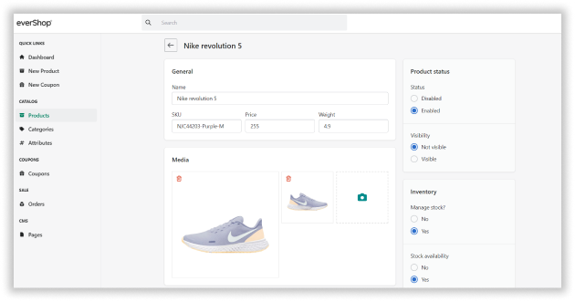
Inspired by leading ecommerce platforms, EverShop includes a fully-featured admin panel built with React. It provides all the tools you need to manage your products, orders, and customers.
The admin panel is also designed to be extensible and customizable. Developers can easily add new features to the admin panel without modifying the core source code.

Customizable Storefront
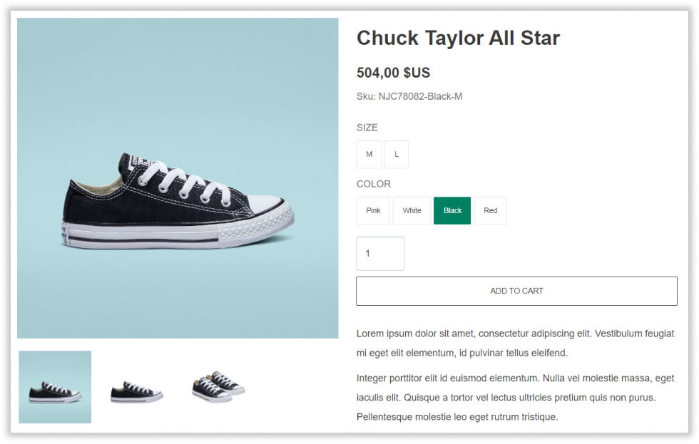
The EverShop frontend is designed to optimize storefront customization, with highly extensible themes being the central customization mechanism.
info
Check out the theme documentation here.

System Requirements
Before installing EverShop, ensure your system meets the following requirements. This guide covers the necessary software, hardware, and environment specifications for optimal performance.


Overview
EverShop is a modern e-commerce platform built on Node.js and PostgreSQL. It requires specific system configurations to run efficiently and securely.

Operating System
EverShop is cross-platform compatible and can run on:
- Linux (Ubuntu 20.04 LTS or later, CentOS 8+, Debian 10+)
- macOS (10.15 Catalina or later)
- Windows (10 or later, Windows Server 2019+)
Recommended
For production environments, we recommend using Linux-based systems (Ubuntu Server or CentOS) for better performance and stability.

Software Requirements

Node.js
Required Version: Node.js 20.x or higher
- Download from nodejs.org
- We recommend using the LTS (Long Term Support) version
- Verify installation: node --version
Version Compatibility
Node.js versions below 20.x are not supported and may cause compatibility issues.

NPM (Node Package Manager)
Required Version: NPM 9.x or higher
- NPM is included with Node.js installation
- Verify installation: npm --version
- Update NPM if needed: npm install -g npm@latest

PostgreSQL Database
Required Version: PostgreSQL 13 or higher
- Download from postgresql.org
- Recommended: PostgreSQL 15+ for improved performance
- Verify installation: psql --version
Database Configuration Requirements:
- An empty PostgreSQL database for EverShop
- Database user with full privileges (CREATE, ALTER, DROP, INSERT, UPDATE, DELETE)
- UTF-8 character encoding
- Recommended extensions: pg_trgm for full-text search
Database Setup
During installation, EverShop will automatically create the necessary database schema and tables. Ensure your database user has sufficient privileges.

Hardware Requirements

Minimum Requirements
Suitable for development and testing environments:
- CPU: 2 cores
- RAM: 2 GB
- Storage: 10 GB available disk space
- Network: Stable internet connection for package installation

Recommended Requirements
For production environments and optimal performance:
- CPU: 4+ cores
- RAM: 4 GB or more
- Storage: 20 GB+ SSD storage
- Network: High-speed internet connection with low latency
Performance
For stores with high traffic or large product catalogs (10,000+ products), consider scaling up to 8 GB RAM and using SSD storage for better database performance.

Development Environment (Optional)
For developers working on EverShop customization or extension development:

Required Tools
- Git (version 2.x or higher) - for version control
- Code Editor - VS Code, Sublime Text, or similar
- Docker (optional) - for containerized development

Additional Dependencies
When running EverShop in development mode, you'll need to install additional dev dependencies manually:
npm install --save-dev @types/node typescript @parcel/watcher @types/config @types/express @types/pg @types/react execa
See the Installation Guide for the complete development setup steps.

Network and Security Requirements

Firewall Configuration
Ensure the following ports are accessible:
- Port 3000 - Default EverShop application port (configurable)
- Port 5432 - PostgreSQL database port (if remote database)
- Port 443 - HTTPS (for production with SSL)
- Port 80 - HTTP (redirects to HTTPS)

SSL/TLS Certificate
For production environments:
- Valid SSL/TLS certificate (Let's Encrypt, commercial CA, or similar)
- Configured reverse proxy (Nginx, Apache, or similar)

Browser Requirements

Admin Panel
The EverShop admin panel supports:
- Chrome/Edge (latest 2 versions)
- Firefox (latest 2 versions)
- Safari (latest 2 versions)

Storefront
The customer-facing store supports:
- Modern browsers with ES6+ support
- JavaScript enabled
- Cookies enabled

Docker Requirements (Optional)
If using Docker for deployment:
- Docker: 20.10 or higher
- Docker Compose: 2.0 or higher
- Sufficient resources allocated to Docker containers (2GB+ RAM)

Cloud Platform Compatibility
EverShop can be deployed on various cloud platforms:
- AWS (EC2, ECS, Elastic Beanstalk)
- Google Cloud Platform (Compute Engine, Cloud Run)
- Microsoft Azure (Virtual Machines, App Service)
- DigitalOcean (Droplets, App Platform)
- Heroku
- Railway
info
EverShop requires a persistent Node.js server process with PostgreSQL access. It is not compatible with serverless platforms (e.g., Vercel, Netlify Functions) that don't support long-running processes or sessions.

Checking Your System
Before installing EverShop, verify your system meets the requirements:

Check Node.js Version
node --version
# Should output: v20.x.x or higher

Check NPM Version
npm --version
# Should output: 9.x.x or higher

Check PostgreSQL Version
psql --version
# Should output: psql (PostgreSQL) 13.x or higher

Check Available Disk Space
Linux/macOS:
df -h
Windows:
wmic logicaldisk get size,freespace,caption

Next Steps
Once your system meets all requirements:
- Proceed to the Installation Guide
- Set up your PostgreSQL database
- Install EverShop using your preferred method

Troubleshooting

Common Issues
Node.js version mismatch:
- Use nvm (Node Version Manager) to manage multiple Node.js versions
- Switch to Node.js 20: nvm install 20 && nvm use 20
PostgreSQL connection issues:
- Verify PostgreSQL service is running: systemctl status postgresql (Linux)
- Check database connection settings in EverShop configuration
- Ensure firewall allows PostgreSQL connections
Insufficient permissions:
- On Linux/macOS, you may need to use sudo for global npm installations
- Consider using nvm to avoid permission issues

Installation guide
The following installation guides will guide you step-by-step to create a new EverShop project and get it started.
info
Please check this document for the system requirements list.

Install EverShop Using create-evershop-app command
npx create-evershop-app my-evershop-app
The create-evershop-app command will create a new folder named my-evershop-app and install all of the dependencies for you.

Install EverShop Using Docker
You can get started with EverShop in minutes by using the Docker image. The Docker image is a great way to get started with EverShop without having to worry about installing dependencies or configuring your environment.
curl -sSL https://raw.githubusercontent.com/evershopcommerce/evershop/main/docker-compose.yml > docker-compose.yml
docker-compose up -d
The Docker image will start a fresh EverShop installation with the default configuration. You can access the site at http://localhost:3000 and the admin panel at http://localhost:3000/admin.
info
To create a new admin user, terminal into the Docker app container and run the following command:
npm run user:create -- --email "your email" --password "your password" --name "your name"
caution
The public Docker image is for installing EverShop in your local environment only. If you are looking for a development solution, please check the development section below.

Install EverShop manually using Npm

Step 1: Install The @evershop/evershop Npm Package
@evershop/evershop is the core of the EverShop platform. It contains all of the core modules like catalog, checkout, order.
Install the @evershop/evershop Npm package
npm init -y
npm install @evershop/evershop

Step 2: Install the core Npm scripts
Open the package.json file and add the following scripts:
Add the core npm scripts to package.json
{
"scripts": {
"setup": "evershop install",
"build": "evershop build",
"start": "evershop start",
"dev": "evershop dev",
"seed": "evershop seed",
"start:debug": "evershop start --debug",
"user:create": "evershop user:create",
"user:changePassword": "evershop user:changePassword"
}
}

Step 3: Run the installation script
Before running this script, make sure that you have an empty Postgres database ready for EverShop.
info
Please check this document for the system requirements list.
The interactive setup wizard will prompt you for:
- Database connection details — host, port, database name, user, and password
- Admin user details — full name, email, and password (minimum 8 characters, must contain at least one letter and one digit)
Once you provide this information, the setup script will:
- Create a .env file in your project root with the database connection settings
- Create the media and public directories
- Set up the database schema (create all required tables)
- Run all database migrations
- Create your administrator account
Installation script
npm run setup
info
The .env file created by the setup script contains your database credentials:
DB_HOST="localhost"
DB_PORT="5432"
DB_NAME="evershop"
DB_USER="postgres"
DB_PASSWORD="your_password"
DB_SSLMODE="disable"
You can edit this file later to change your database connection settings. See the Database documentation for more options including SSL configuration.

Step 4: Folder permission
EverShop needs to write some files to the disk. So you need to make sure that the following folders have the write permission:
- public/
- .evershop
- .log
- media

Step 5: Run the build command to build the site
Build the site
npm run build

Step 6: Run the start command to start your store in production mode
Start the site
npm run start
Your site will start at http://localhost:3000.
Admin panel can be accessed at http://localhost:3000/admin.
info
By default EverShop will start at port 3000. You can change the port by setting the PORT environment variable.

Upgrade EverShop
To upgrade EverShop to the latest version:
Step 1: Install the latest version
npm install @evershop/evershop@latest
Step 2: Rebuild your store
npm run build
Step 3: Restart your store
npm run start
Database migrations are run automatically when the application starts, so any schema changes in the new version are applied for you.

Demo Data Seeding
After installation, you can populate your store with demo data using the seed command. This is useful for development and testing.
npm run seed
This command will populate your store with sample products, categories, and other data.
info
Demo data seeding is intended for development and testing environments only. Do not use it in production.

For Developers
If you are a developer and want to start the project in development mode, there are some additional steps you need to follow.

Install Additional Dev Dependencies
To run the project in development mode, you need to install additional dependencies. These are not required for production but are essential for development:
npm install --save-dev @types/node typescript @parcel/watcher @types/config @types/express @types/pg @types/react execa

Adding the workspace configuration
Open the package.json and add the following configuration:
Adding the workspace configuration
{
"workspaces": [
"extensions/*",
"themes/*"
]
}
This allows each extension and theme to function as an independent package with its own dependencies.

Start the project in development mode
Start the site in development mode
npm run dev
Your store will start at http://localhost:3000 with hot-reloading enabled. Changes to React components update instantly in the browser.

The debug mode
The start:debug script (already added in Step 2) starts the production server with debug logging enabled:
Start the site in debug mode
npm run start:debug
This outputs detailed middleware execution timings and request processing information.
info
Debug mode is enabled by default when you run the dev command, so you don't need to use start:debug during development.

Dockerize Your Project
Dockerizing your EverShop project allows you to create a portable, self-contained environment for your application. Below is a guide to creating your own Docker image and managing persistent data like media files.

Handling Persistent Media Files
When you dockerize your application, it's crucial to handle the media directory correctly. This directory contains user-uploaded files (like product images) and should not be copied directly into the Docker image. If you do, any uploaded files will be lost whenever the container is rebuilt.
There are two primary approaches for managing media files:
- Docker Volumes: This approach mounts a directory from your host machine into the container. Files are stored on the host, so they persist even if the container is removed. This is suitable for single-server deployments or local development.
- Cloud Storage: This approach uses a cloud storage service like Amazon S3 or Azure Blob Storage. This decouples file storage from your application container entirely, which is essential for auto-scaling environments and provides better durability and performance.
Production Recommendation
For any production environment, we strongly recommend using cloud storage (like AWS S3 or Azure Blob Storage). This approach is more scalable, reliable, and secure than using local volumes. It prevents data loss, simplifies backups, and is essential if you ever plan to run your application across multiple servers.
EverShop provides official extensions for AWS S3 and Azure Blob Storage to make this integration seamless.

1. Building Your Docker Image
Here is an example Dockerfile. Note that we have removed the COPY media ./media line.
Dockerfile
FROM node:20-alpine
WORKDIR /app
RUN npm install -g npm@10
COPY package*.json .
# Copy your custom theme.
COPY themes ./themes

# Copy your custom extensions.
COPY extensions ./extensions

# Copy your config.
COPY config ./config

# DO NOT copy the media folder. It will be handled by a volume.

# Copy your public files.
COPY public ./public

# We must copy translations to the image as they are required for the build.
COPY translations ./translations

# Run npm install.
RUN npm install

# Build assets.
RUN npm run build

EXPOSE 3000
CMD ["npm", "run", "start"]

2. Using Docker Compose with a Volume
This docker-compose.yml file demonstrates how to build the image and attach a volume for the media directory.
docker-compose.yml
version: "3.8"

services:
app:
build:
context: .
dockerfile: Dockerfile
restart: always
volumes:
- ./media:/app/media # Mounts the host's media folder to the container
environment:
DB_HOST: database
DB_PORT: 5432
DB_PASSWORD: postgres
DB_USER: postgres
DB_NAME: postgres
networks:
- myevershop
depends_on:
- database
ports:
- 3000:3000

#The postgres database:
database:
image: postgres:16
restart: unless-stopped
volumes:
- postgres-data:/var/lib/postgresql/data
environment:
POSTGRES_PASSWORD: postgres
POSTGRES_USER: postgres
POSTGRES_DB: postgres
ports:
- "5432:5432"
networks:
- myevershop

networks:
myevershop:
name: MyEverShop
driver: bridge

volumes:
postgres-data:
With this configuration, any files uploaded to your application will be saved in the media folder on your host machine, ensuring they are not lost.

